Kim, Soo-min

***Are you an introvert or an extrovert?***

There is a saying: “Your clothes are your wings,” but I think personality is more important. I’m an **extrovert**. I’m a **joiner**, an **outdoors person**, and a **weekend warrior**. I take after my father, he’s a very outgoing person, and he’s in sales. My mother’s personality is just the opposite, and, I look more like my mom than my dad. So, in personality I take after my father, and in looks after my mother.

First, I’m a **joiner**. I love doing things with people. For example, I belong to two clubs: an English club and computer club. I’m also on my major’s soccer team. My computer club is also in English because most computer terms are English. We work long hours at the computer club, but that’s OK because I’m also a detail person with along attention span.

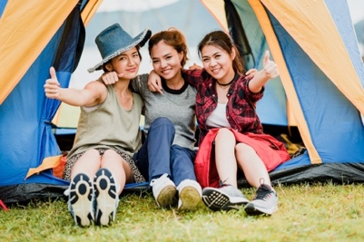Second, I hate staying indoors. I’m an **outdoors person**. I can’t study at home because there are too many distractions. So after school I study in the library. When I’m at home on the weekends it feels like I’m in jail. On Saturday mornings I go jogging, and in the afternoon and evening I meet my friends at Hyewha. Every Sunday after church our family goes mountain hiking and then eat out.

Third, I like to party on the weekends. I’m a **weekend warrior**. During the week I study every night so that my weekends are free to socialize. During the week I get stress, and on the weekends I relieve stress. I meet my friends at BHC in Chongno. I am not a foodie, I eat anything. I’m a party animal this semester. I studied hard for 3 years in high school and I want my reward.

I may not be an average person, but I think that life is short and I want to have fun while I'm young. I just feel more alive when I’m around a lot of people. That is why I’m an **extrovert**. I’m a **joiner**, an **outdoors person**, and a **weekend warrior**. A university is where you learn, and socialize. I plan on doing both. My motto is: *Let’s do it.*

362 words